CAR INSURANCE PROJECT ON TABLEAU

1. **Problem Statement:**

Consider that you are a Lead Data Analyst at an Insurance Claims company that has provided you with the Car Insurance Claims dataset. You have been given a task to explore the data, create different plots and interpret useful insights/findings. Your end goal here will be to create a storyboard that you have to present to the Senior Management and the story has to have an end objective and should follow a logical flow to display that you are heading towards achieving the end objective. This will help the Senior Management in taking some decisive actions on the current claims system in place. This storyboard will be an open-ended story for you to explore various different features in the data and try to showcase different plots. Make sure to have minimum clutter in the plots, follow a consistent color scheme across all the plots, and use proper colors to highlight a specific insight. Moreover, your plots on all the dashboards should be interactive and responsive. There should be 1 dashboard that should cover the summary of the story as well as your recommendations.

1. **Data Dictionary**

|  |  |
| --- | --- |
|  |  |
| Assumption | Car Owner and Driver are same Amounts are in Dollars ($) |
| ID | Identification Variable |
| KIDSDRIV | Number of teenagers among the car owner's children who can drive a car. |
| BIRTH | Date of birth of the driver |
| HOMEKIDS | No of childern the car owner has |
| YOJ | Years on Job. How many years has the owner of the car been working? |
| INCOME | Income of the driver |
| PARENT1 | Is the car owner a Single Parent |
| HOME_VAL | Value of the house owned by the car owner |
| MSTATUS | Marital status of the car owner |
| GENDER | Gender of the driver |
| EDUCATION | Maximum Education level of the driver |
| OCCUPATION | Occupation of the driver |
| TRAVTIME | Time taken to get to work on an average |
| CAR_USE | Purpose of using the car |
| BLUEBOOK | What is the worth of the car. Value of the Vehicle(in dollars) |
| CAR_TYPE | Car type |
| OLDCLAIM | Total claim (in past 5 years - in dollars) |
| CLM_FREQ | Number of claims (in past 5 years) |
| CLM_AMT | If car was in a crash, what is the currently claimed amount(in dollars) |
| CAR_AGE | Age of car |
| URBANICITY | Where the car is being driven primarily |

1. List of calculated fields, Parameters and new columns
2. Calculated fields

* Work Exp:-

IF [YOJ] <= 4 THEN '0-4 yrs'

ELSEIF [YOJ] >=5 AND [YOJ] <= 9 THEN'5-9 yrs'

ELSEIF [YOJ] >=10 AND [YOJ] <= 14 THEN'10-14 yrs'

ELSE '15-20 yrs'

END

* Car Age Range:-

IF [Car Age] <= 4 THEN '0-4 yrs'

ELSEIF [Car Age] >=5 AND [Car Age] <= 9 THEN'5-9 yrs'

ELSEIF [Car Age] >=10 AND [Car Age] <= 14 THEN'10-14 yrs'

ELSEIF [Car Age] >=15 AND [Car Age] <= 20 THEN'15-20 yrs'

ELSE '>20 yrs'

END

1. New columns :- claim freq no and car ages
2. Parameters:-

* Claim Freq no
* Top N Customers
* Top N Customers by Claim Freq
* Top N Customers by Old Claim

1. Below are all the dash boards created
2. Dashboard :Occupation Distribution

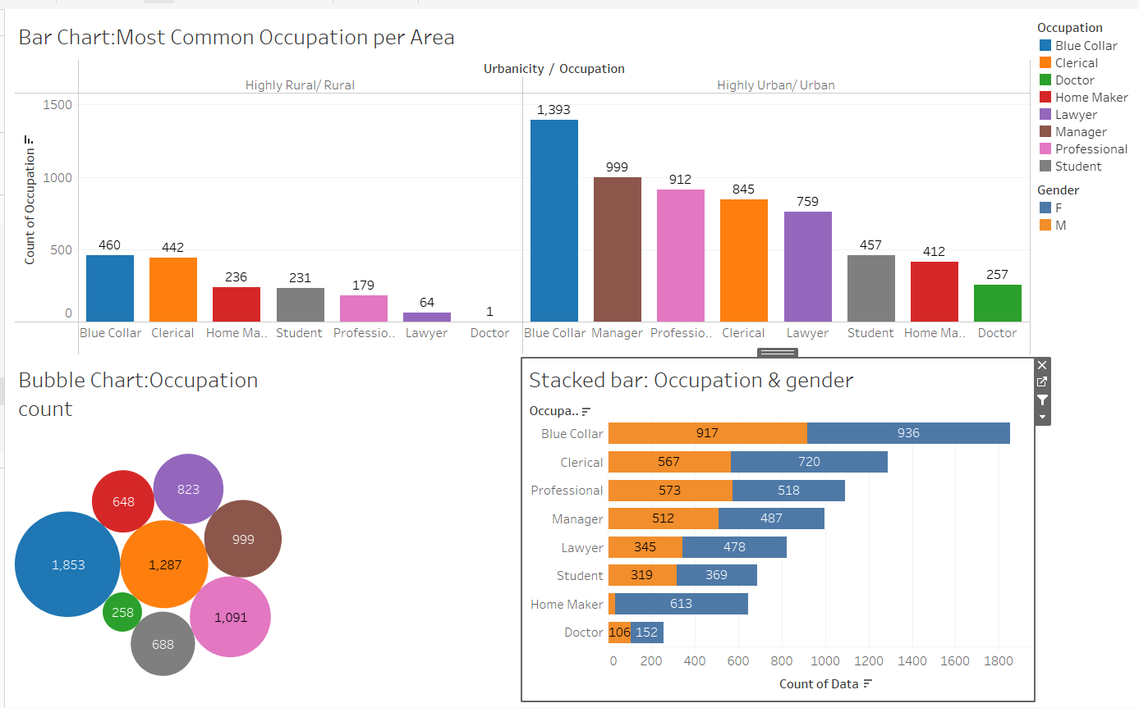

1. Dashboard :Education Distribution

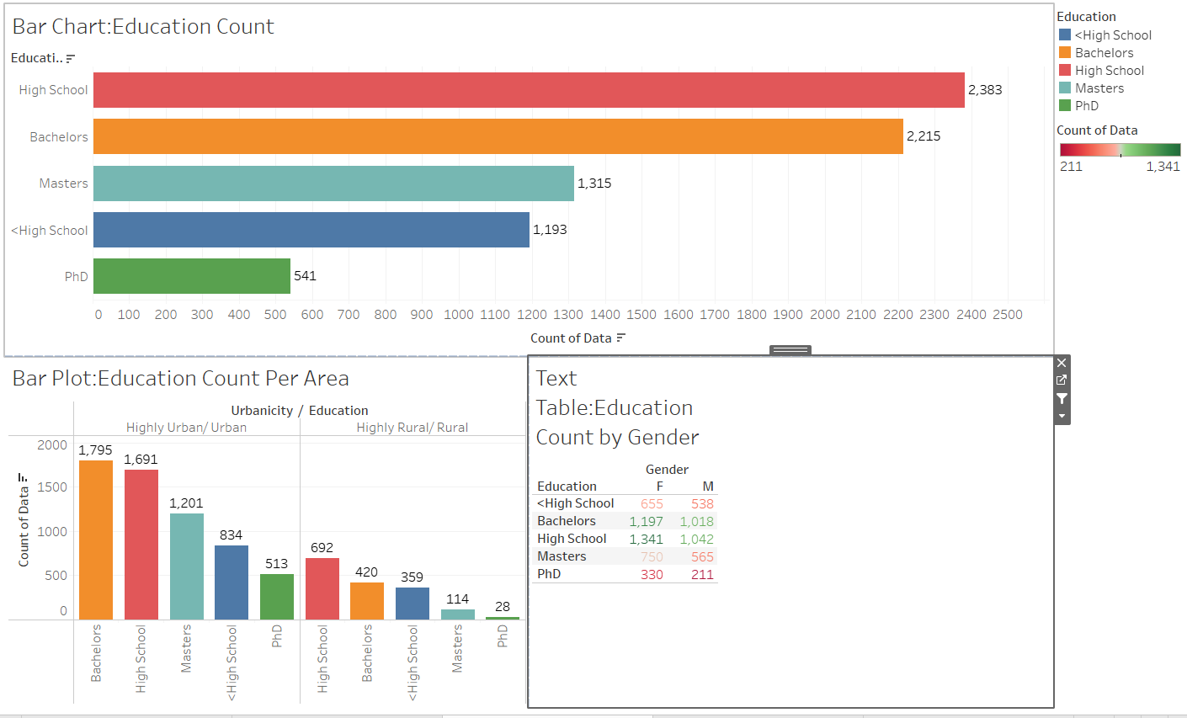

1. Dashboard Income Distribution

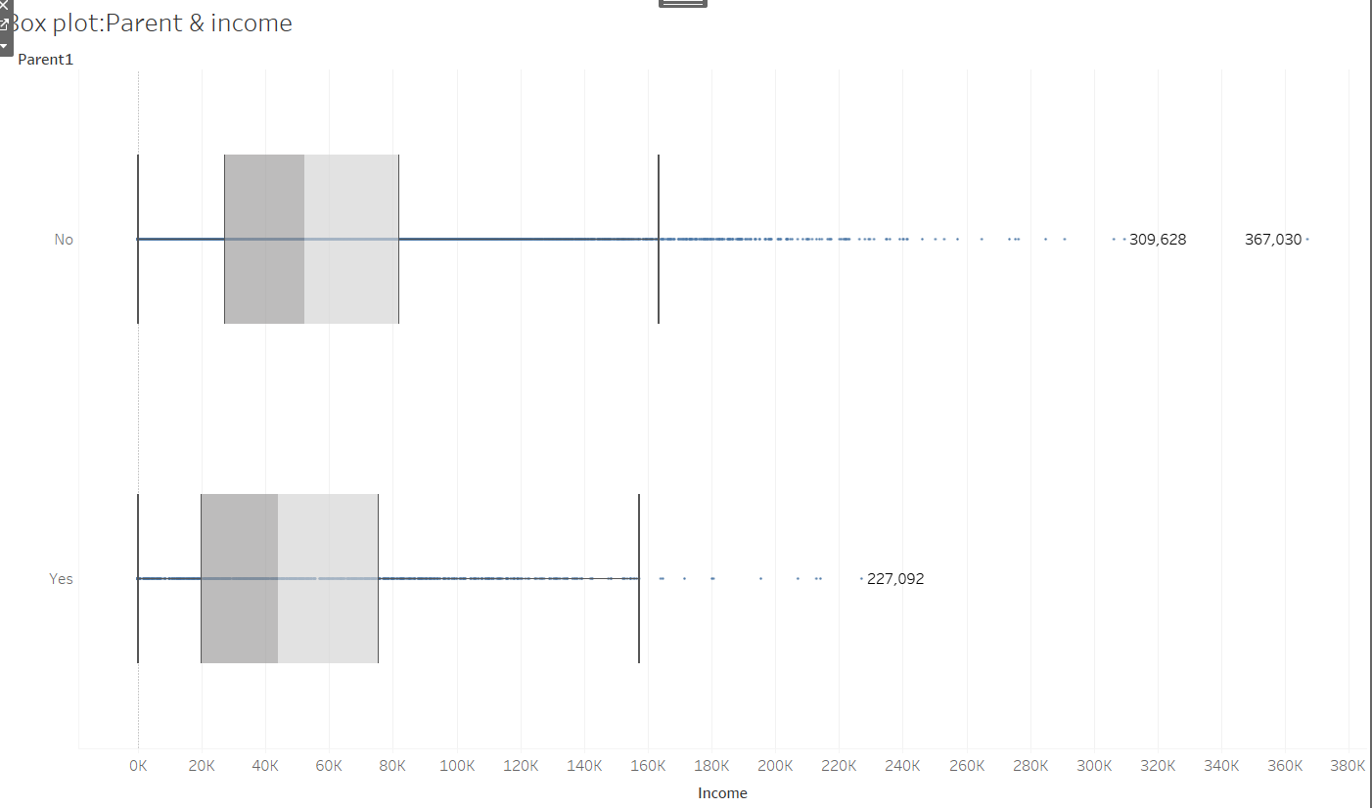

1. Dashboard :Income distribution as per occupation ,gender ,area and mstatus

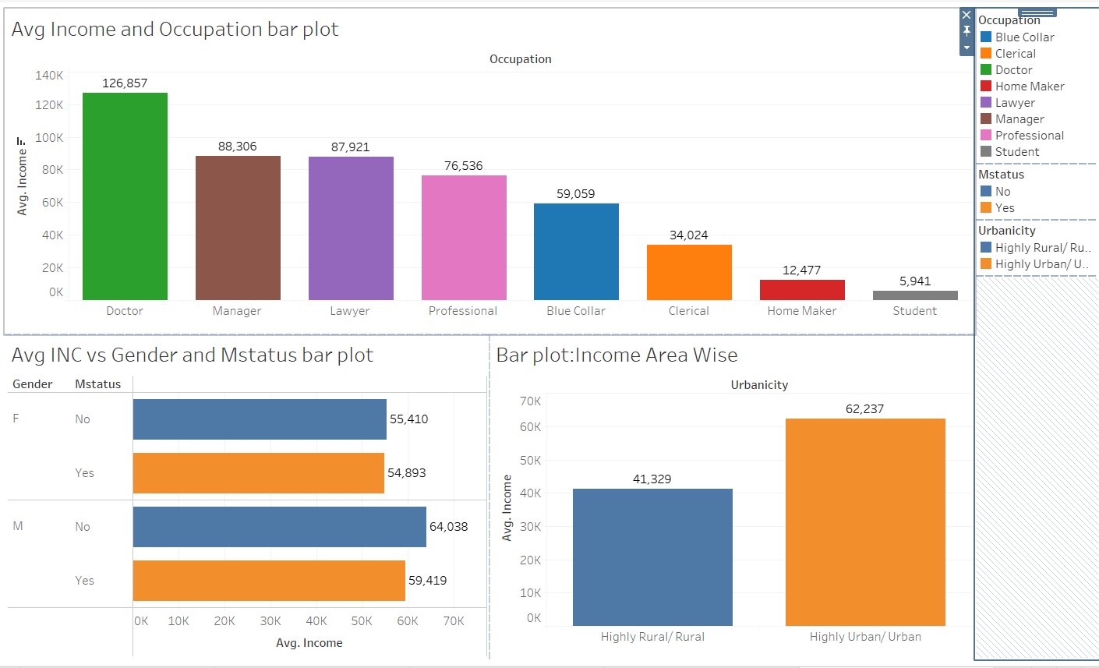

1. Dashboard :More details as per work experience

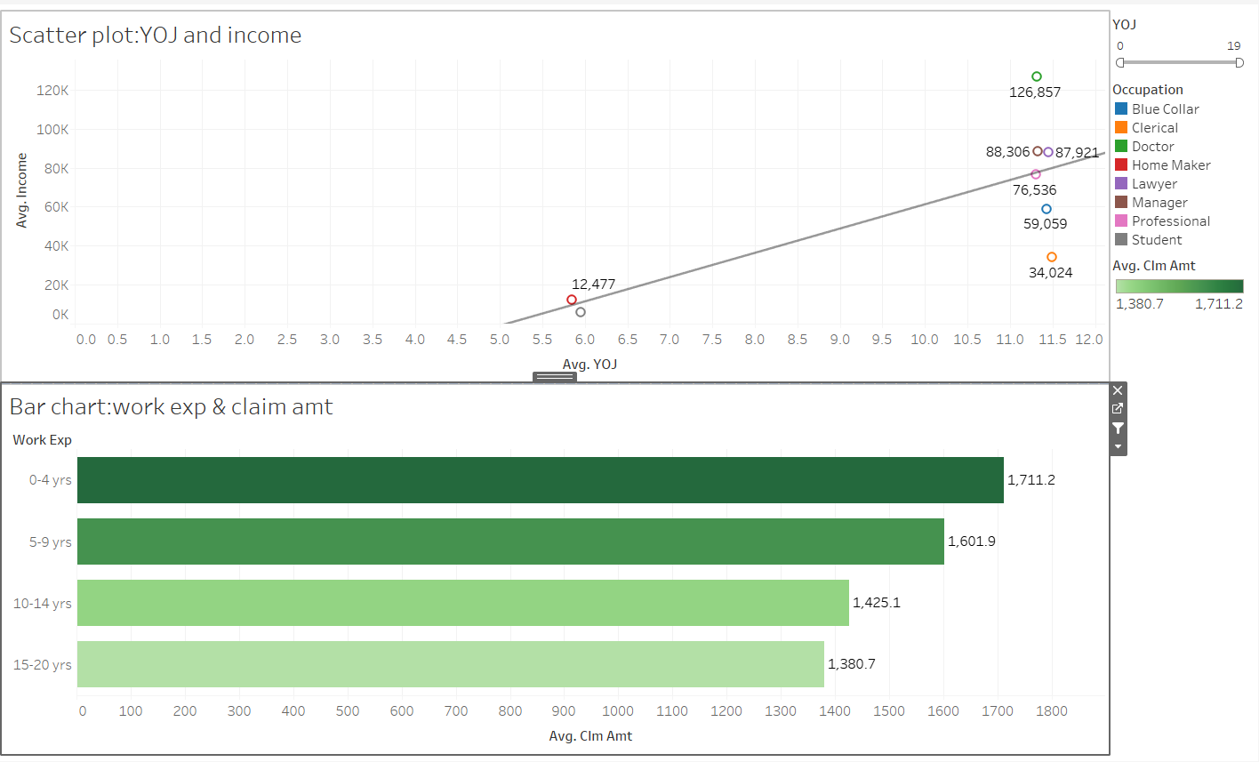

1. Dashboard :Claim Amt as per Education & occupation

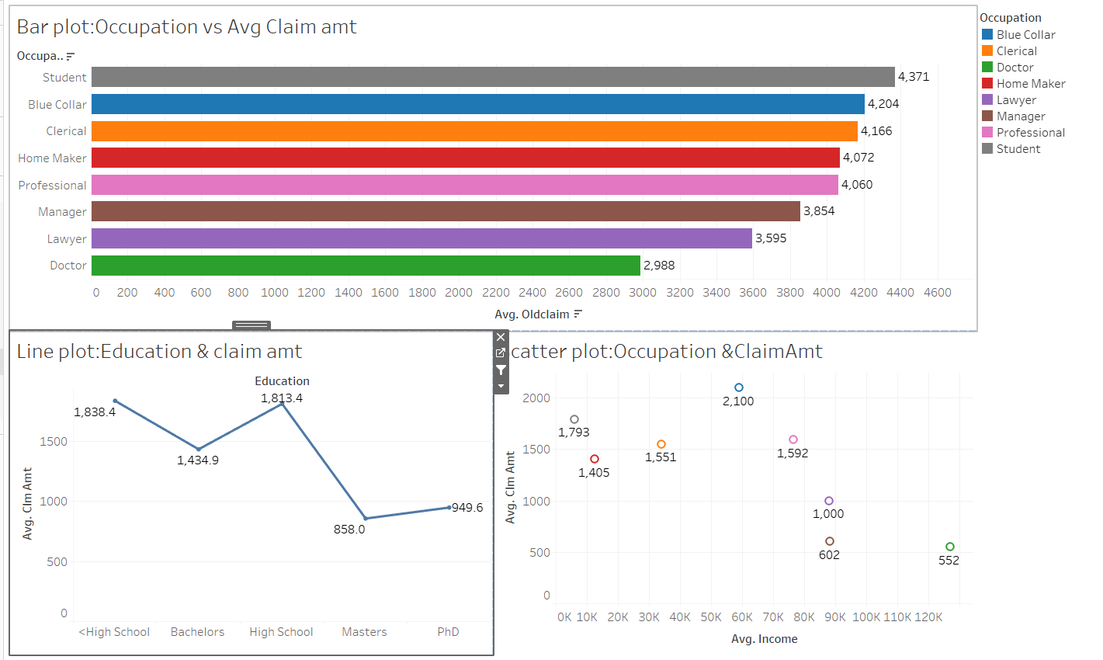

1. Dashboard: Claim Freq Distribution

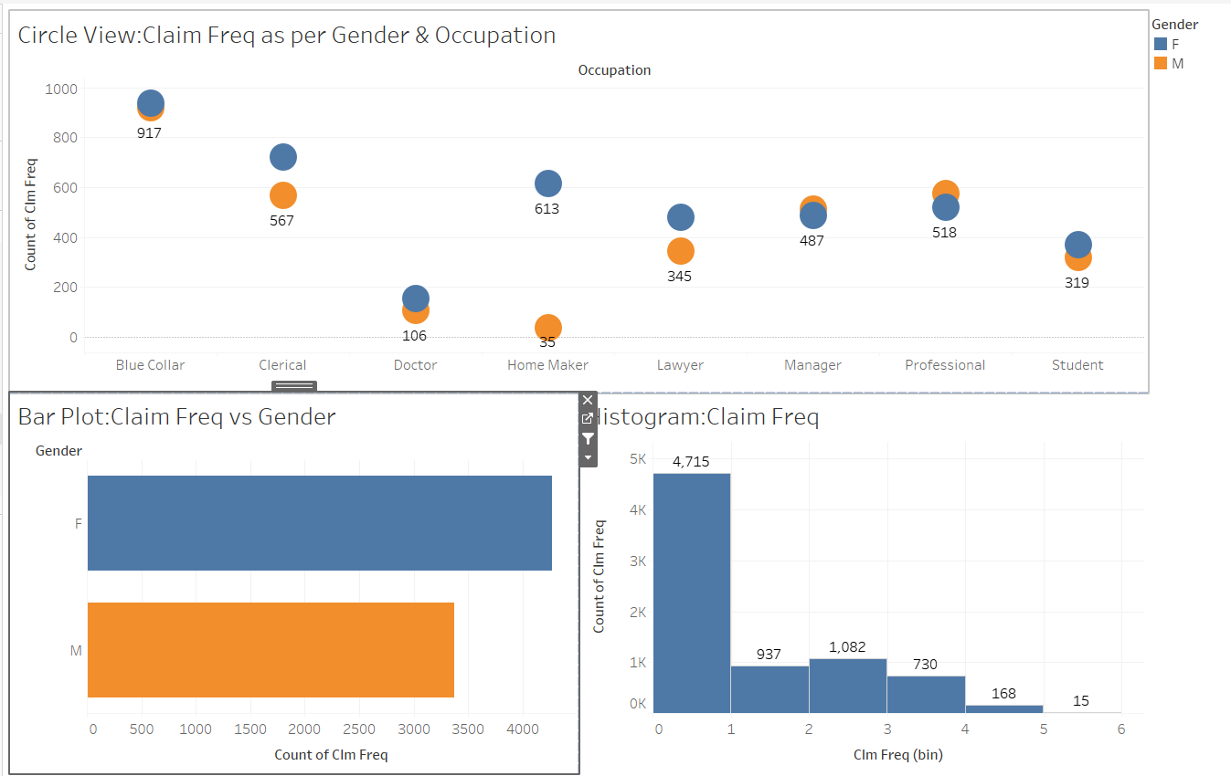

1. Dashboard : Car Value Distribution

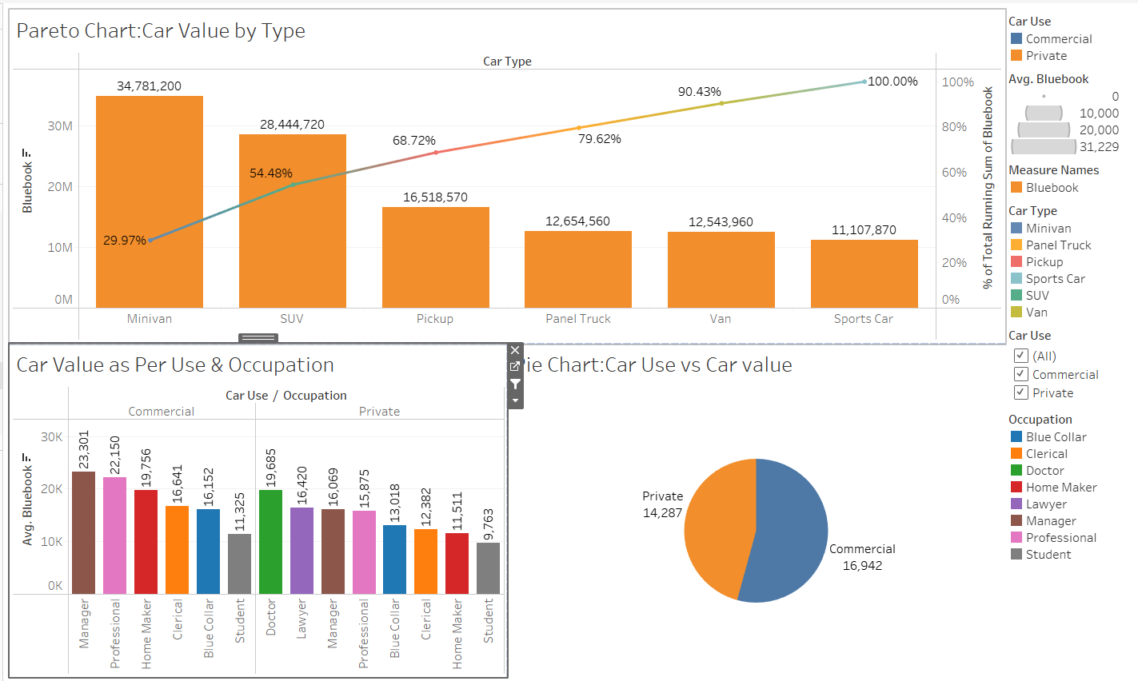

1. Dashboard : Top N customers as per claim amt, old claim and freq

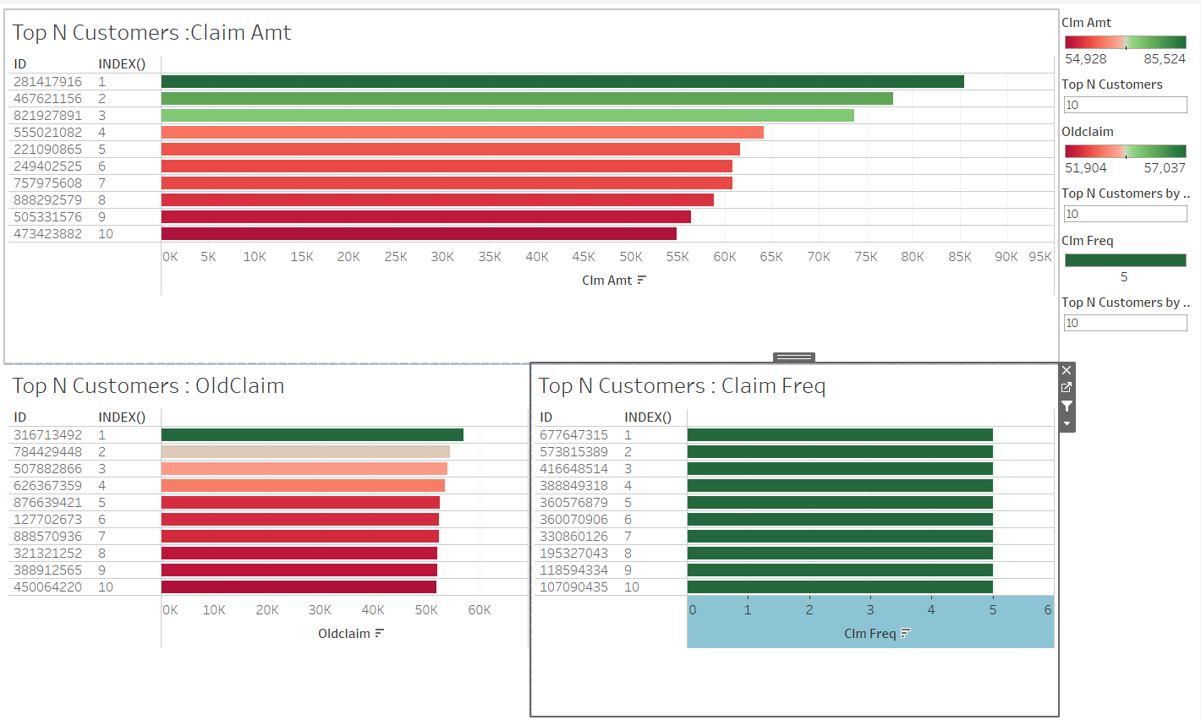

1. Dashboard :Car type as per gender, income, area and age

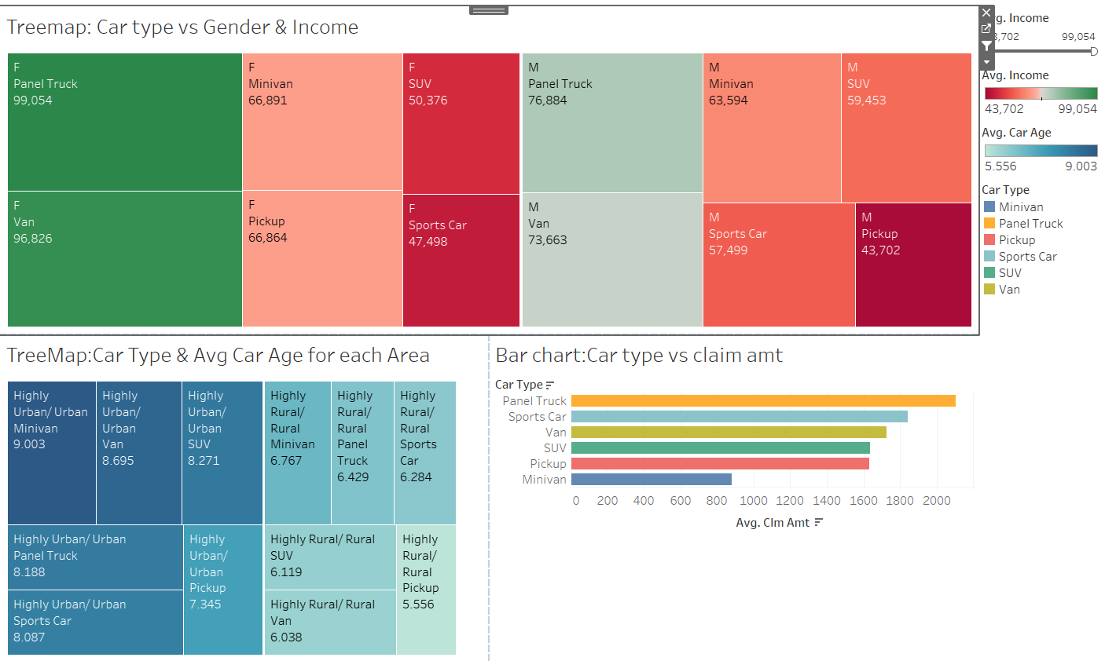

1. Dashboard : Home value Distribution

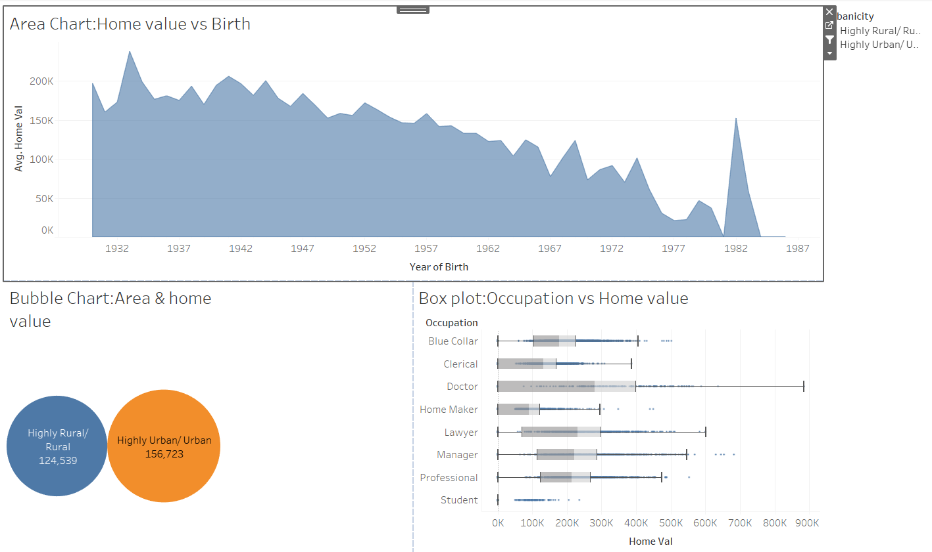

1. Dashboard: Claim amt and freq for different cars

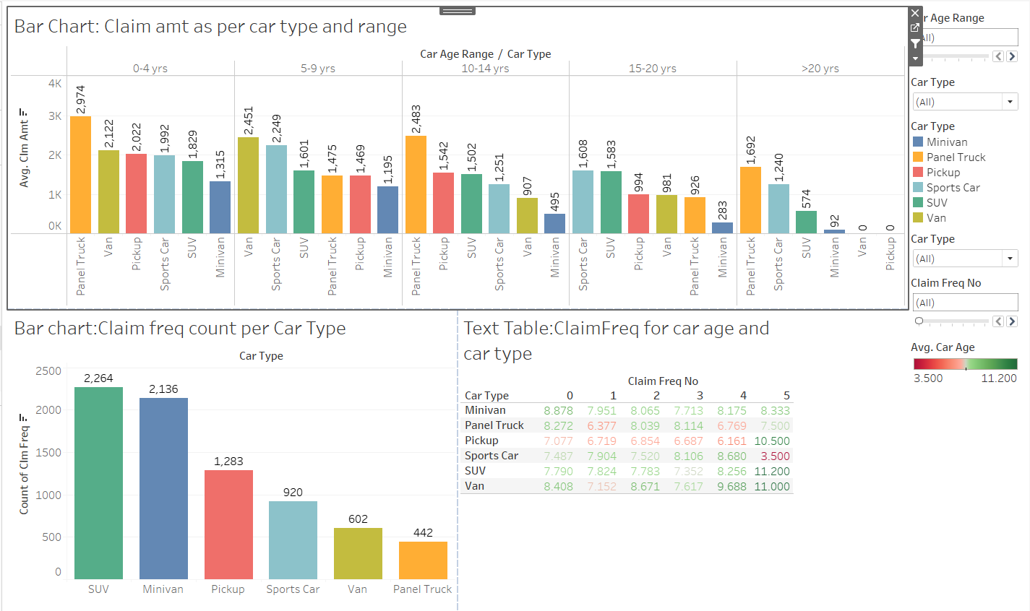

1. Dashboard :Claim amts for different factors

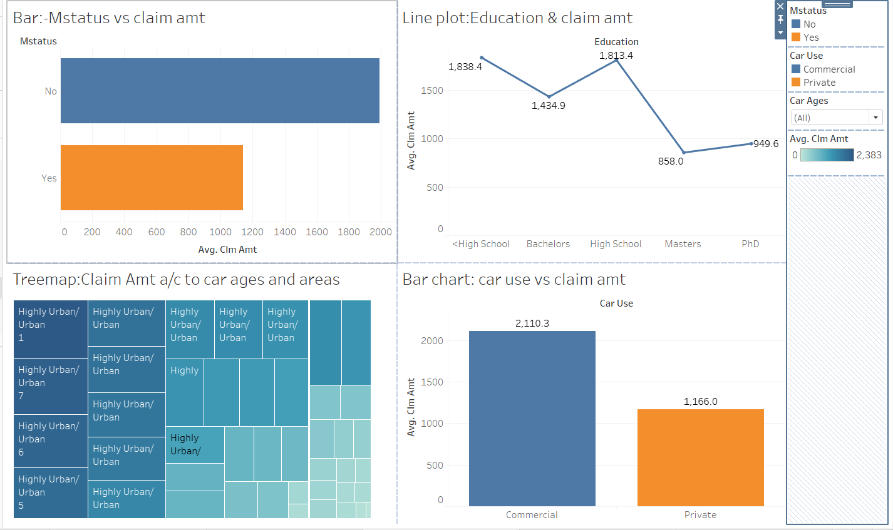

1. Dashboard :Claim data Prediction

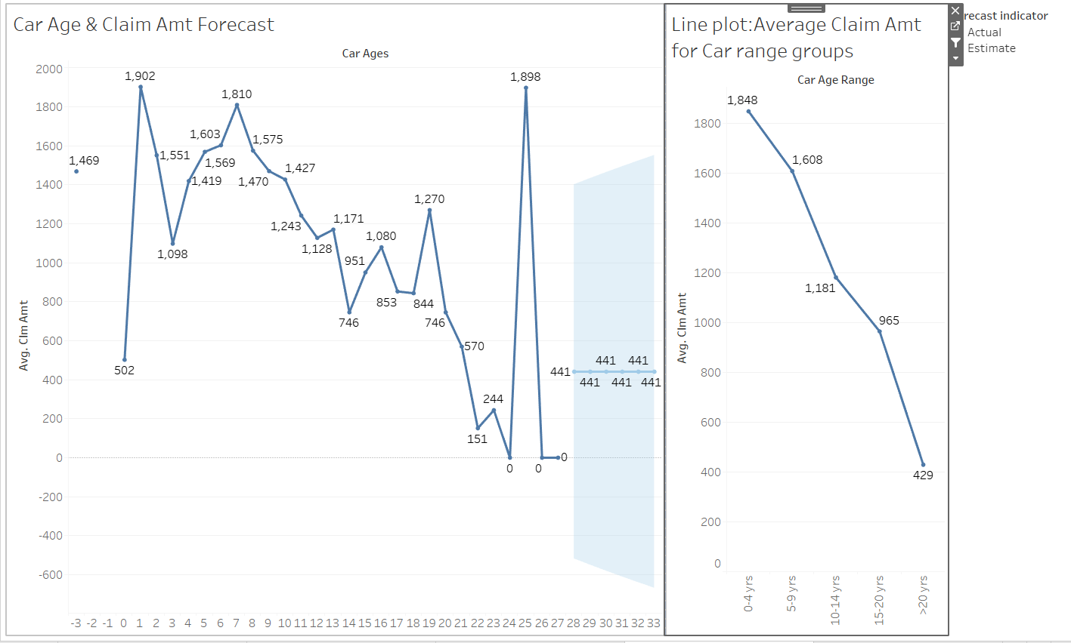

1. Dashboard : Travel time distribution

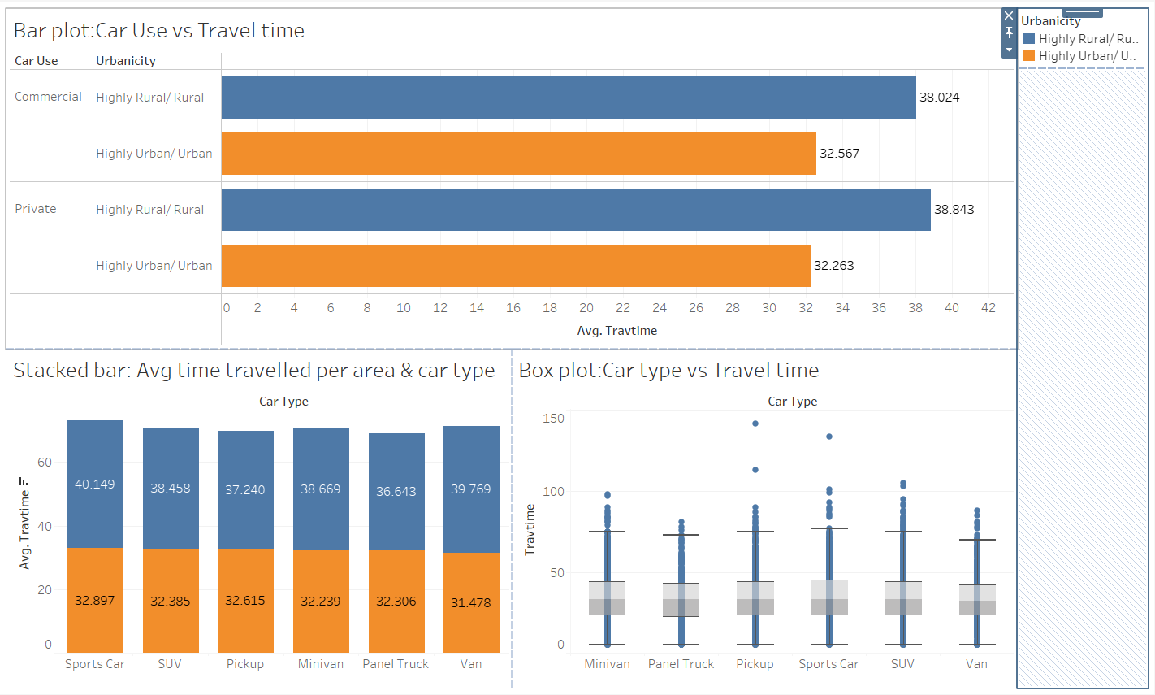

INSIGHTS

1. Most of the people have blue collared jobs in highly rural area and highly urban area followed by clerical jobs in rural area and manager in urban area.
2. Doctor is least common jobs in both rural and urban area.
3. There are more number of people who are at least high school graduate.
4. Less number of people are PhD.
5. There are more bachelor graduate in urban areas and very less phD.
6. There are more high school graduate in rural areas and very less PhD.
7. Most males and females are at least high school graduate and very less phDs.
8. Doctors have highest income. On an average they earn $126,857.
9. Students as usual have lowest earning of $5941.
10. Unmarried males have higher income than married males.
11. Married females have alomost same income as unmarried females.
12. Income in urban areas is more as compared to rural area.
13. Doctor has highest avg income and least claim amt. Blue collars have highest claim amt.
14. Home makers are higher on claim amount as compared to thier lower income.
15. Clerical jobs with PhD have highest home value.
16. Students with bachelors degree have lowest home value.
17. The vehicles belonging to Managers and professionals are used for commercial purpose.
18. Vehicles used by Doctors and Lawyers are used for private purpose.
19. Vehicles with age ranging between 0-4 yrs and 10-14 yrs have highest Claim Amount.
20. Minivan with age greater than 20 has lowest claim amount.
21. Married people have highest claim amount.
22. Cars used for commercial purpose have highest claim amount.
23. High school graduates have highest claim amount.
24. Vehicles with higher car age have lowest claim amt than newer cars.

Link to the tableau notebook :

<https://public.tableau.com/app/profile/poonam.palandurkar/viz/CarInsuranceStory_16955249071230/CarInsuranaceStory>